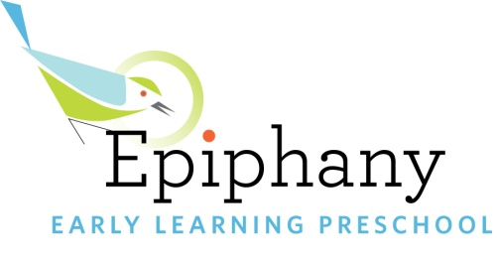

Epiphany Early Learning is Hiring!

OUR LEARNING COMMUNITY – “Nothing without Joy!”

At Epiphany Early Learning, we are a caring community of children, families and educators who draw inspiration from the schools of Reggio Emilia, Italy, and who keep our values at the heart of every aspect of our practice with children and families. As a preschool serving children 18 months-5 years, we hold the following values at the core of our work:

- Relationship at the Center. We believe in growing empathy and understanding between children, teachers and the community; teaching children to work collaboratively with other individuals; and helping children build a strong and meaningful relationship with the natural world. In all of these arenas, children and adults co-construct knowledge and build curriculum together.

- Children as Capable and Deserving of Respect. We hold an image of the child as strong and competent. We trust each child in our care to be an active participant in his or her own educational experience.

- Learning Through Play. We believe that children have the right to learn within a context of exploration and play and we do everything we can to protect what we see as the essential elements of childhood - long stretches of uninterrupted time, open-ended materials, real and meaningful work, and plenty of time in the natural world- all explored through play.

- Social Justice. We value cultural relevancy and anti-bias learning and believe that it is essential to continue our own individual and collective professional development as an organization committed to undoing institutionalized racism.

- Teachers as Researchers. Teachers are life-long learners and valued resources. Children, families and the field as a whole, benefit when teachers are given regular opportunities to continue to grow professionally and contribute to the field in turn.
Teacher Job Description – Join Our Community!

We are looking for educators who approach their daily work with joy and reflection, seek true partnership with families, and delight in side-by-side work with children and co-teachers.

Teachers work as part of an equal teaching team with the support of a mentor teacher to provide learning experiences for children in multi-age classrooms ranging in age from 2 ½ to 5. Teachers plan curriculum, set out provocations and invitations for play, observe and document children’s learning, and share documentation and partner with families in their children’s learning.

This position is full-time, Monday-Friday, though we are also seeking a part-time afternoon teacher as well.

The most competitive candidates will have experience with emergent curriculum and Reggio-inspired practice, documentation of children’s learning, anti-bias and culturally-relevant practices, formal education in the field of early childhood education and three or more years of experience working with 18 months-5-year-old children. We value diversity and what it brings to our lives. All are welcome and encouraged to apply!
Compensation

Epiphany Early Learning aims to provide a work-life balance that values family, health, and engaging practice. Our teachers are supported in their ongoing professional development through planning time, team meetings, mentorship, in-service training, workshops, conferences, professional tours, and a thriving, joyful community of colleagues.

Starting salary range is commensurate with experience and education. We offer an excellent benefits package including health/dental/optical insurance, three weeks of vacation in the first year, Metro Orca bus pass, paid sick leave, short-term disability, extensive on-site professional development opportunities and a matching retirement plan.
Please send resume and cover letter to the attention of:

Julie Bisson, Director
Epiphany Early Learning Preschool
juliebisson@epiphanyearlylearning.org

