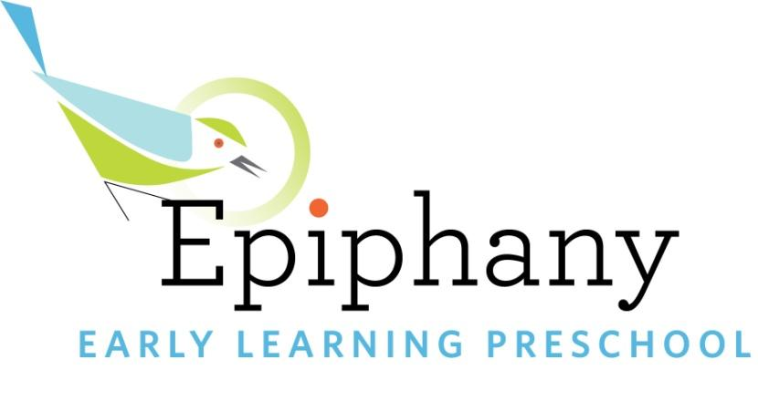

Date

Hi there,
My daughter Laila is in your music class on Fridays @ 9:30am on Capitol Hill and is having the best time and I've been surprised by how few other families in her preschool have done classes with you. We have our annual auction for her preschool coming up on April 29th to raise money for our educators and the tuition assistance program, and I'm writing to ask you to consider donating a gift-card or spot in one of your classes, which will certainly be met with gratitude from our parents, teachers, and staff, and will hopefully help you promote your business to a loyal community. I've attached the procurement form here -- any donation is tax-deductible as we are a 501(C)3.

Epiphany Early Learning is a non-profit, non-sectarian Reggio-inspired preschool that opened its doors in 2011. We have four classrooms of 60 children, between ages 2 and 5, and are housed in a newly renovated space on the campus of Epiphany Church near the center of Madrona.

Our families and alumni families are a diverse and committed group of parents, who are intent on supporting the businesses and people that support us. Your donation will be prominently displayed at our auction and classroom art walk -- an evening event where parents walk our halls and enjoy our children's art.

Thank you in advance for your consideration. Please let me know if I can answer any questions you might have, 206.915.5072.

Best,
Ali Amadon, Laila's Mom
Epiphany Early Learning Preschool Family

